TO-BE Process

* Level 1 – Claim Process

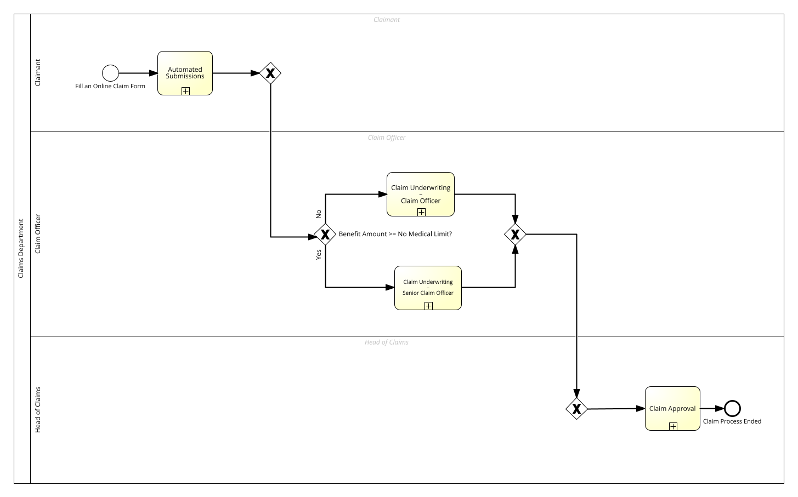

* Level 2 – Automated Submission

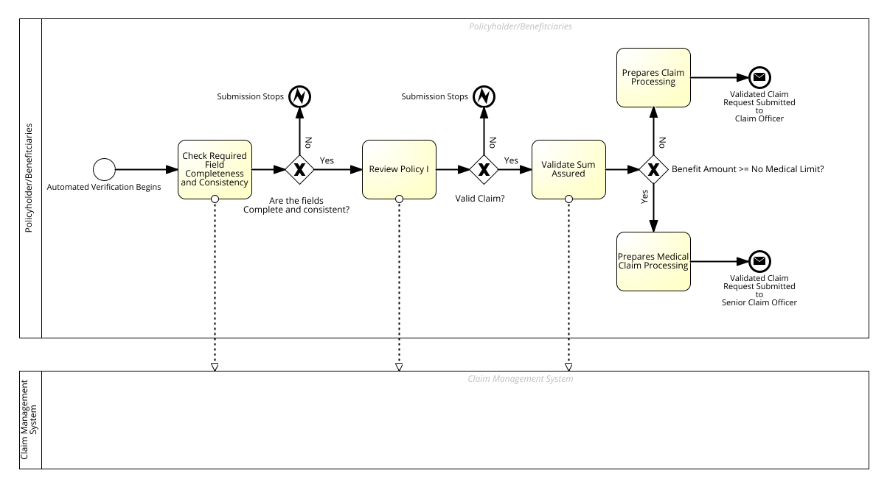

* Level 2 – Claim Underwriting – Claim Officer

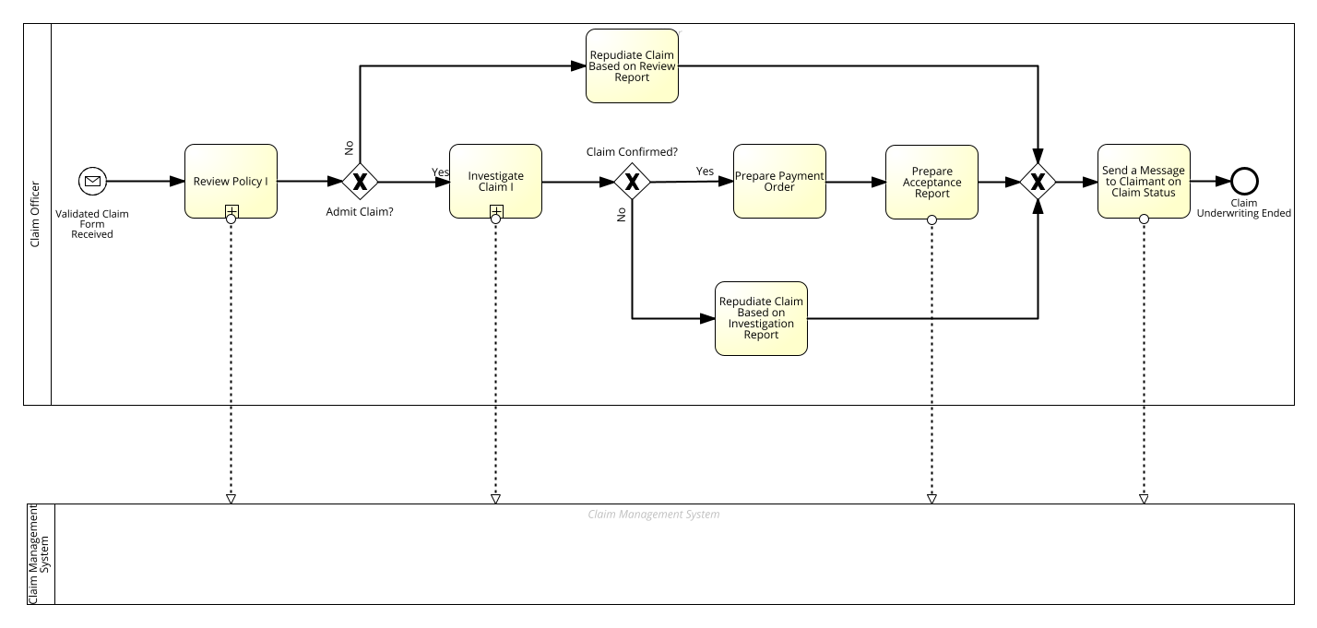

* Level 2 - Claim Underwriting – Senior Claim Officer

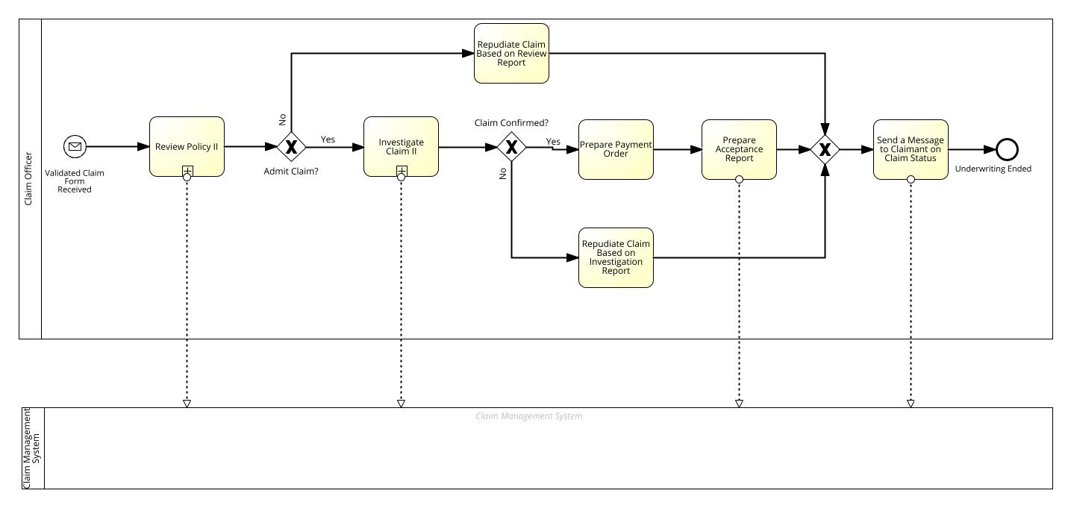

* Level 3 - Review Process

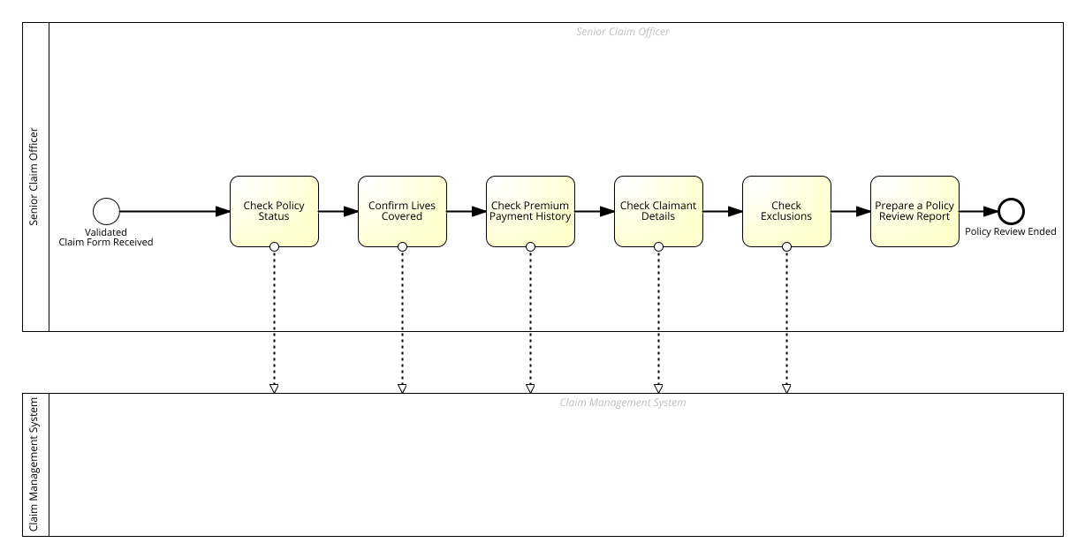

* Level 3 - Investigation Process

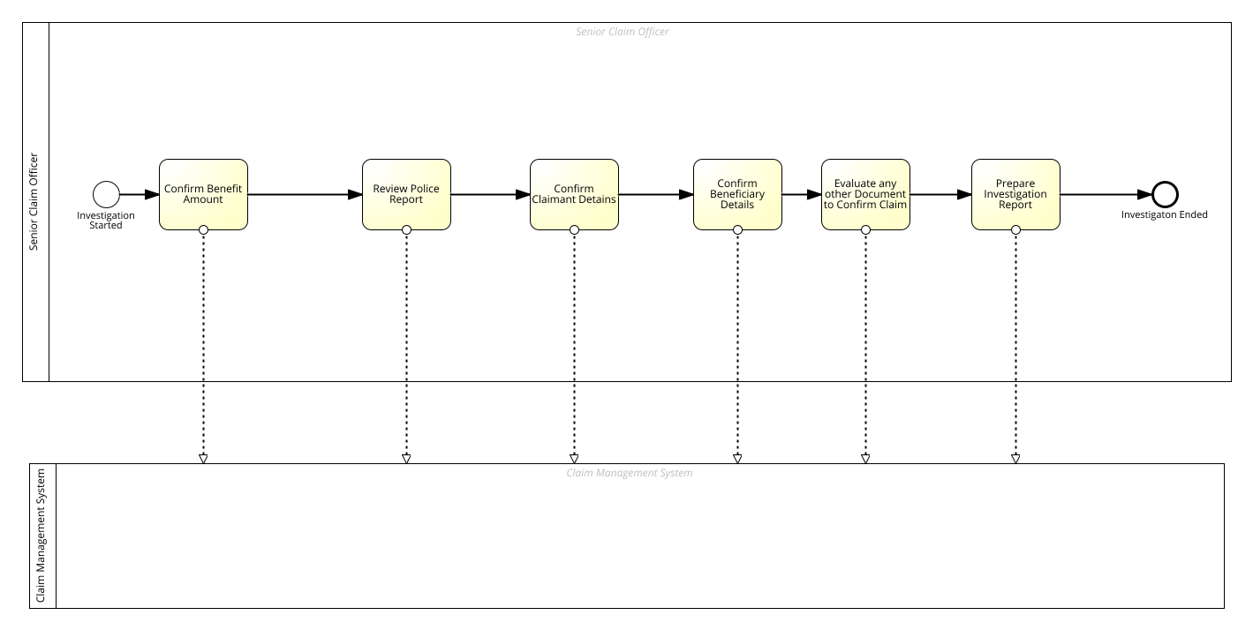

* Level 2 – Claim Approval

